DIS-AM,C-Taino-Cohoba Plate

TAINO COHOBA TABLE:  9" X 7" X 2". WEIGHT: 7 LBS. ORIGINALLY FROM A DOMINICAN REPUBLIC COLLECTION.

THIS DENSE ROCK IS COVERED WITH APPROPRIATE DEPOSITS. APPROXIMATELY 1000-1500 AD. ARTIFACT IS WELL DETAILED.

## Ex nchern has been an eBay member since Sep 08, 2007.

## 

Sold by [nchern](http://myworld.ebay.com/nchern) ( [1453](http://feedback.ebay.com/ws/eBayISAPI.dll?ViewFeedback&userid=nchern) )

### Delivery package 1 of 1

Estimated delivery Monday, Dec 21, 2015

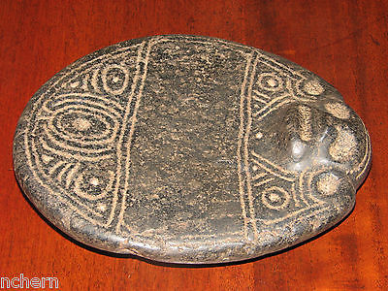

#### [TAINO PRE COLUMBIAN COHOBA TABLE. DENSE STONE.](http://www.ebay.com/itm/351598080828)

|  |  |
| --- | --- |
| Item price | $599.99 |
| Quantity | 1 |
| Item number | 351598080828 |
| Shipping service | USPS Priority Mail |

## Shipping address

Ralph J Coffman Jr

149 Atlantic Ave

Swampscott MA 01907-2427

United States

## Order total

|  |  |
| --- | --- |
| Subtotal | $979.53 |
| Shipping | $32.49 |

**Total**

$1,012.02